Welcome to

‘Building Together’

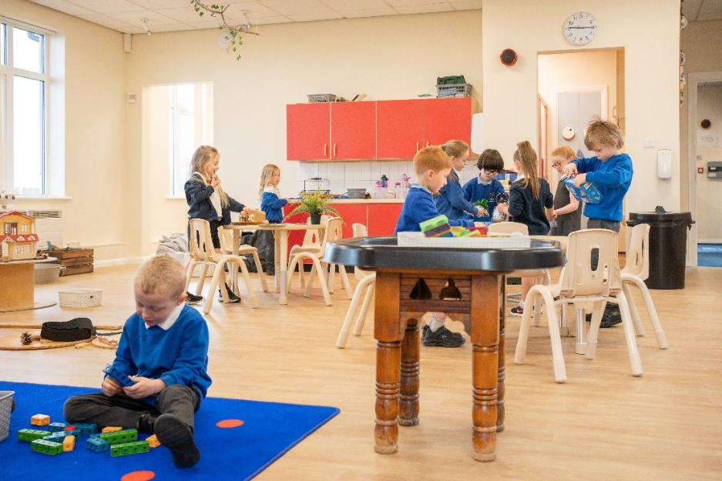

Esh C.E. Primary School

Nursery and Reception Brochure

Front Street

Esh Village

Durham

DH7 9QR

Head Teacher: Mr A Park

Tel: 0191 3731324

Email: [office@eshprimary.org.uk](mailto:office@eshprimary.org.uk)

The early years of a child’s education are very important ones and we aim to ensure that each child has a happy and successful start to school life.

This booklet gives some general information and tells you about some of the activities we complete in Class 1 and how you can help your child.

If in doubt about anything – please ask.

Further information about school can be found in the School Brochure or on our School Website <https://eshprimary.org.uk/>

Beginning school can be both a daunting time and an exciting time for you and your child. Your child may have had the experience of attending a pre-school or nursery school and may know a little about school routines. However, this may be your child’s first time away from home. Whatever your child’s experience, everyone in school hopes to make your child’s time with us happy and rewarding. We aim to create a safe and caring environment where your child will feel secure, confident and valued.

This booklet contains information about some of the activities which take place in our Early Year’s Class, how the work is organised and how you can help us and how you can help your child at home.

We look forward to your child becoming part of this class and the school, and we hope that they do too.

Mrs Alison James and Mrs Kaye Wilson

(Nursery/Reception Class Teachers)

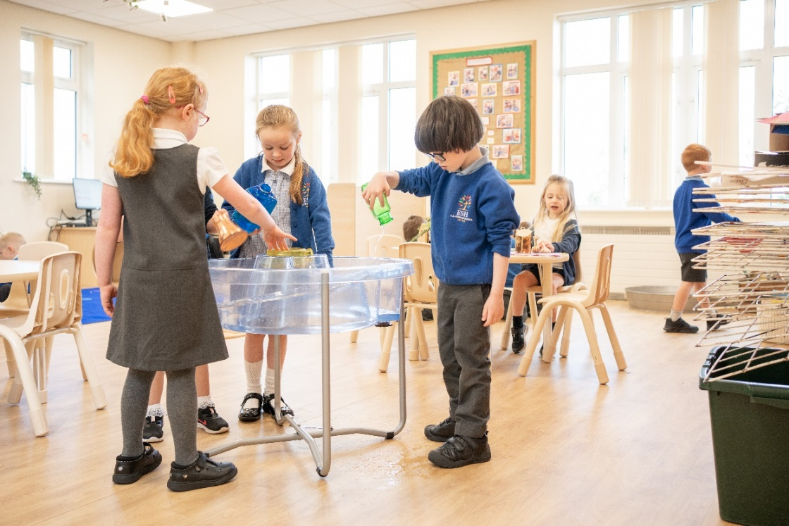

**Nursery Options**

* Mornings
* Afternoons
* 2.5 days – Monday & Tuesday all day, Wed am
* 2.5 days – Wed pm, Thursday & Friday all day
* 30 hours – 5 full days

**Please note we have revised times and charges for Nursery in September in line with new legislation:**

**Morning session**

* 8.30 – 11.30am
* Option of flexible drop-off between 8.30 and 8.50am to fit around siblings

**Lunch and afternoon session (Lunch is charged at £2.95)**

* 11:30 – 2:30

**Optional additional 45 minutes (Charged at £5)**

* 2.30 – 3.15
* Option of flexible collection between 3.00 and 3.15pm to fit around siblings

**Additional Sessions**

**For children in Nursery less than 30 hours, additional morning or afternoon sessions can be booked at a cost of £15 per session – subject to availability.**

**School Uniform**

School uniform is very simple. A blue or white polo shirt and black or grey trousers, joggers or leggings are all that is required for Reception and Nursery. If children want to wear a jumper or cardigan this should also be blue. A school badge is not required on uniform, but we do have 3 suppliers who are able to provide this along with other items such as coats, hats, P.E bags and book bags:

**Etika**

**Parents can now order online via the link below. Any orders received before 3.30pm Monday to Friday will be dispatched the same day.**

[**https://etikauniforms.co.uk/esh-ce-primary-school/**](https://etikauniforms.co.uk/esh-ce-primary-school/)

**Moette Clothing  
The Old Chapel  
Quebec Street  
Langley Park  
Tel: 0191 3735995**

**Their shop is open Monday to Friday 9.00am-5.00pm and items can be tried on for size.**

**Emblematic LTD  
Unit 26  
North Tyne Industrial Estate  
Benton  
Newcastle  
NE12 9SZ  
Tel: 0191 2701449**

**Esh Primary School Uniforms can be ordered online at**[**http://studentuniform.co.uk/eshps022**](http://studentuniform.co.uk/eshps022)

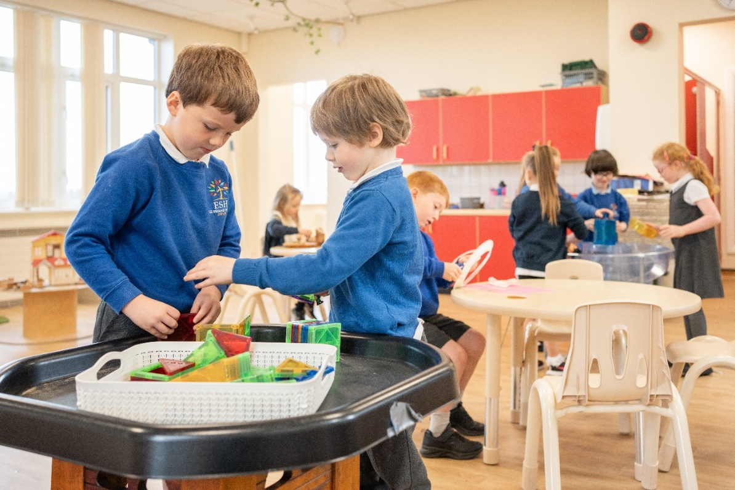

**Our staff**

* Head Teacher – Mr Park
* Nursery and Reception Teachers - Mrs James & Mrs Wilson
* Nursery and Reception Teaching Assistants – Miss Hunter and Miss Young.

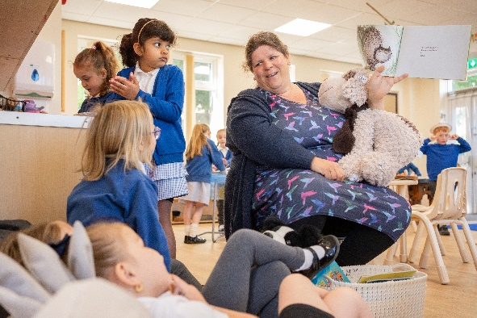

Hello! My name is Mrs James and I teach Class 1 with Mrs Wilson. I work in school Monday, Tuesday, Wednesday and Thursday. I am looking forward to meeting you and teaching you next year.

I like Class 1 to have lots of fun. I love children’s stories and I love to make them exciting. I enjoy all the activities we do and hope you will too.

I love our newly refurbished classroom. It has been amazing being able to buy some new resources and it will be fully set up when the children return in September for Nursery and Reception children.

My favourite thing about Class 1 is Christmas! I also like to keep in touch through our online learning journey Tapestry where you will be able to see lots of photographs of what your child does in class.

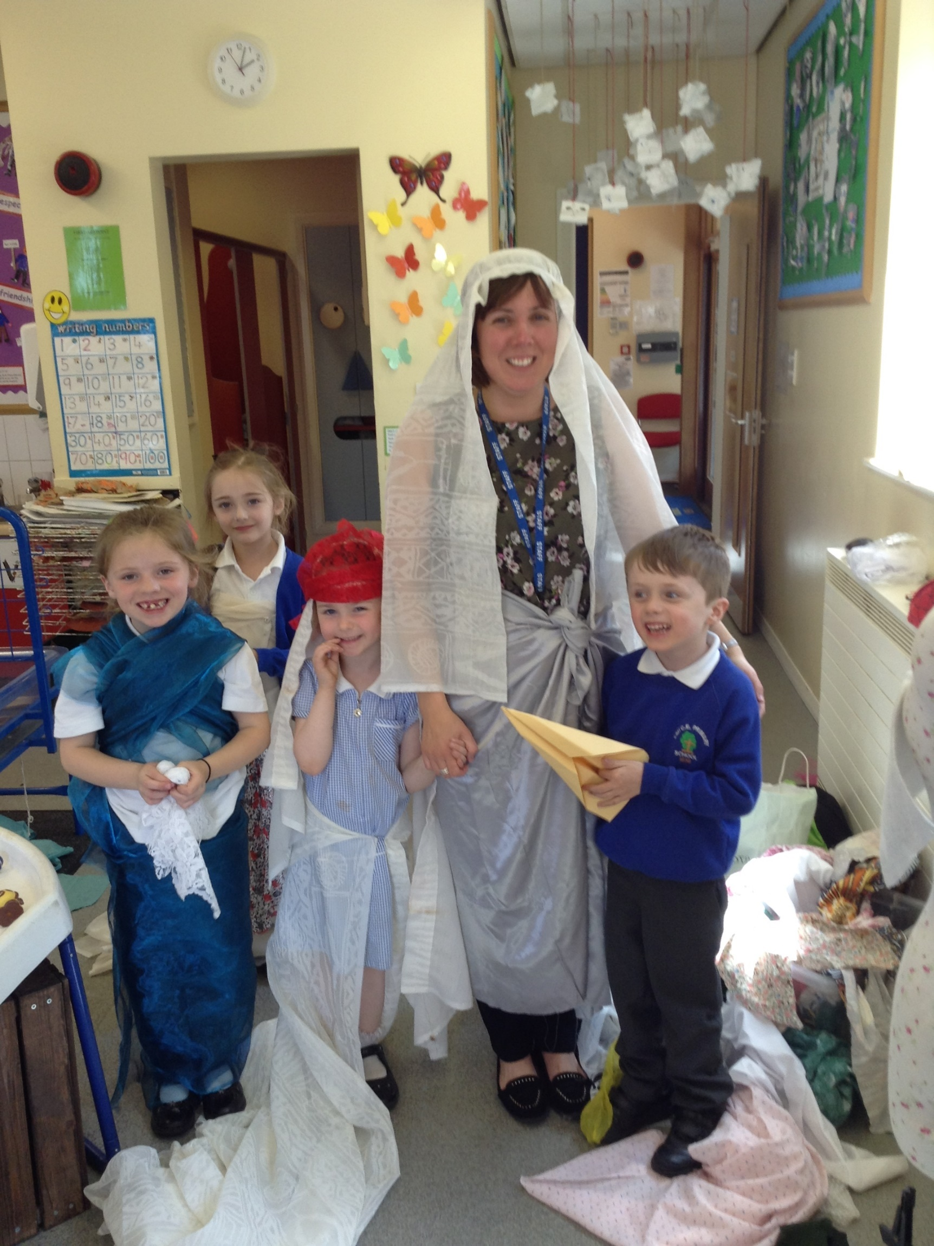

Hello everyone! I am Mrs Wilson and I shall be working with Class 1 every Thursday and Friday. I am really looking forward to meeting everybody in September.

I think Class 1 is a very happy place to be. It is a bright, cheerful room and we do lots of fun activities like baking and painting. Sometimes we dress up and we get to make all sorts of things; especially at Christmas and Easter.

We use the outdoor area lots which is especially for Class 1.

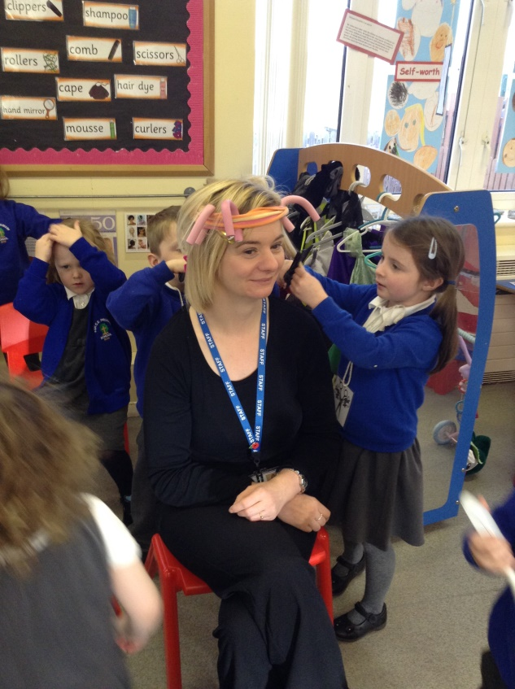

Hi! My name is Miss Hunter and I’m one of the Teaching Assistants in Class 1.

I like all the art and craft activities that we do in Class 1. I love going on school trips.

I like to read Class 1 stories and help you learn new things. It is great to play in Class 1.

Like Mrs James, my favourite time of the school year is Christmas.

**What is it like in Class 1?**

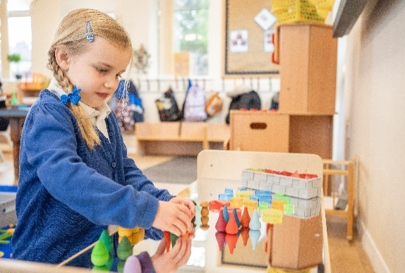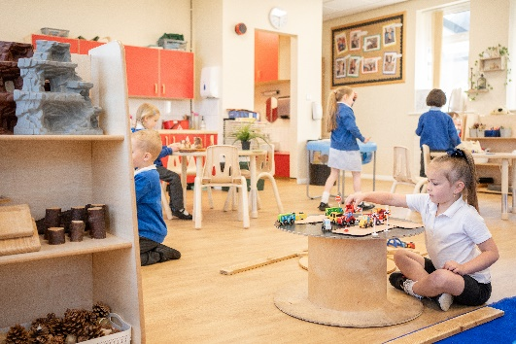

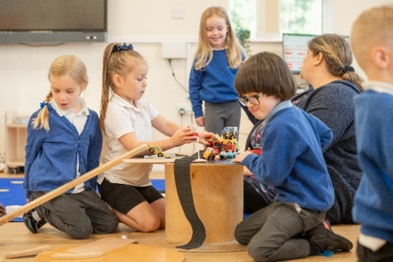

Creative

Happy

Challenging

Fun

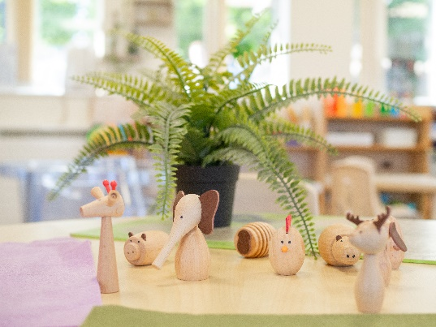

Exciting

Collaborative

Friendly

Busy

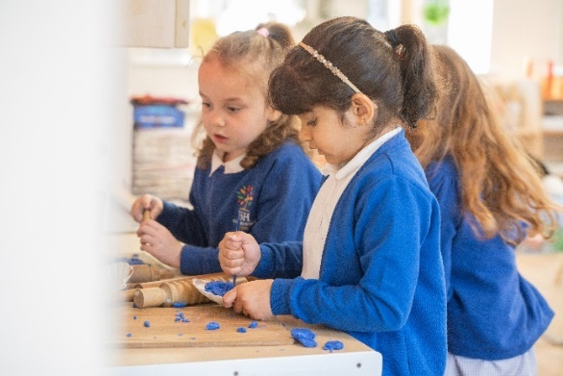

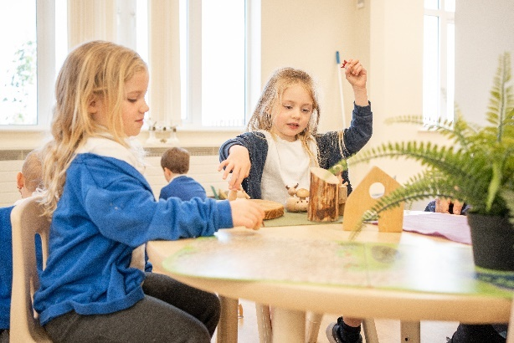

**Outdoor Learning**

Our outdoor learning area has a large sandpit, a mud kitchen, areas for building, water play, areas for climbing and balance, plants to look for mini-beasts in and places to play with small world toys like dinosaurs or other animals.

We also have a nature area where we often do forest school activities.

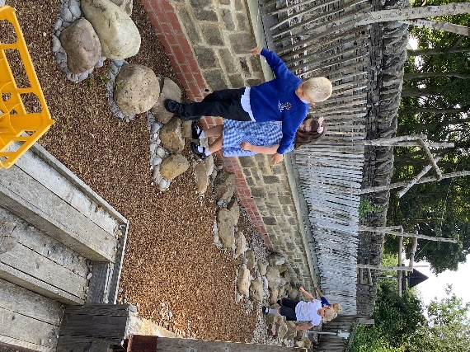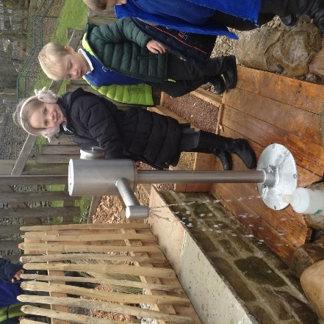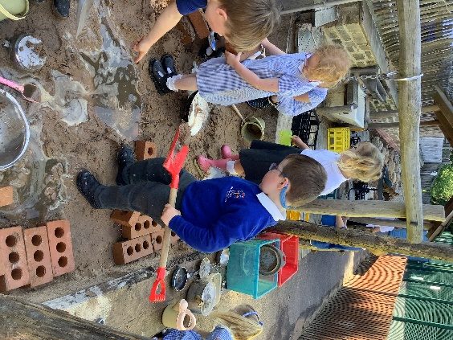

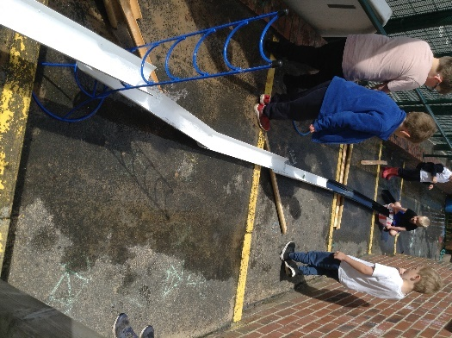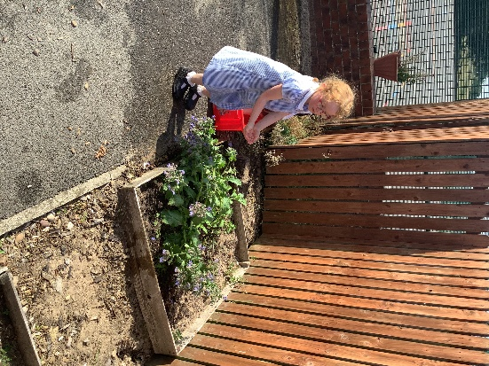

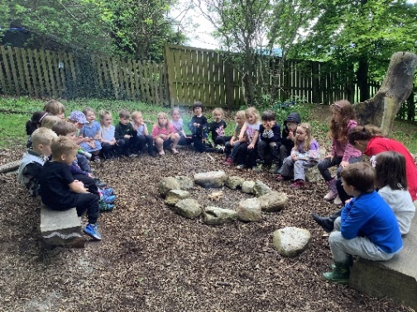

**Seven Areas of Learning**

Your child will be in a mixed class of Nursery and Reception children. Nursery and Reception children are part of the Early Years Foundation Stage (EYFS) for children from birth to five years. We aim to stimulate your child’s natural curiosity and love for learning through play, exciting activities and a wide range of experiences. Above all, we want it to be fun! In Class 1 we follow a mixture of topics proposed by the teachers and also plan from the children’s interests. Topics are carefully planned with all staff involved to make sure the children are covering what is expected of them and we also plan with the children after observing the play they initiate.

The Early Years Foundation Stage (EYFS) is split into 7 areas of learning which are explained below. We will follow the statutory Early Years Framework. Teaching and Learning in each of these areas will take place in many different ways:- structured and child-initiated play, learning in the outdoor environment as well as indoors, games, songs and rhymes, stories, and through Information and Communication Technology. Structured or Adult led play or learning is something which the adult usually sets up and the children may have to follow certain instructions for it. Child initiated play is something which the child chooses and follows creating their own rules etc. Adults may be used to scaffold and support child-initiated play or equally this can be fully child led.

The Early Years Foundation Stage Framework follows four overarching principles.

* Every child is a **unique child** who is constantly learning and can be resilient, capable, confident and self-assured.
* children learn to be strong and independent through **positive relationships**.
* children learn and develop well in **enabling environments** with teaching and support from adults, who respond to their individual interests and needs and help them to build their learning over time. Children benefit from a strong partnership between practitioners and parents and/or carers.
* importance of **learning and development.** Children develop and learn at different rates. The framework covers the education and care of all children in early years provision, including children with special educational needs and disabilities (SEND).

The Early Years Foundation Stage Framework splits learning into 7 areas. They are all important and interconnected at this stage and are all there to help support and ignite your child’s natural curiosity and enthusiasm for learning, encourage them to learn and help them to build positive relationships. There are 3 **‘prime’** areas and 4 **‘specific’** areas.

The Prime areas are:-

**Communication and Language**

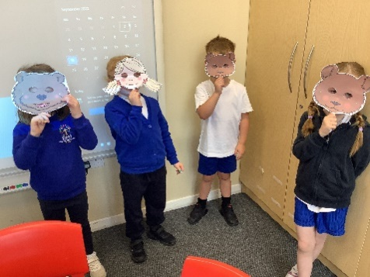

The development of children’s spoken language underpins all seven areas of learning and development. Children’s back-and-forth interactions from an early age form the foundations for language and cognitive development. The number and quality of the conversations they have with adults and peers throughout the day in a language-rich environment is crucial. By commenting on what children are interested in or doing, and echoing back what they say with new vocabulary added, practitioners will build children's language effectively. Reading frequently to children, and engaging them actively in stories, non-fiction, rhymes and poems, and then providing them with extensive opportunities to use and embed new words in a range of contexts, will give children the opportunity to thrive. Through conversation, story-telling and role play, where children share their ideas with support and modelling from their teacher, and sensitive questioning that invites them to elaborate, children become comfortable using a rich range of vocabulary and language structures.

**Personal, Social and Emotional Development**

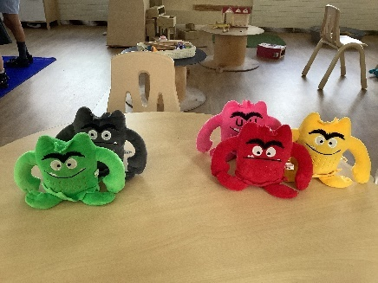

Children’s personal, social and emotional development (PSED) is crucial for children to lead healthy and happy lives, and is fundamental to their cognitive development. Underpinning their personal development are the important attachments that shape their social world. Strong, warm and supportive relationships with adults enable children to learn how to understand their own feelings and those of others. Children should be supported to manage emotions, develop a positive sense of self, set themselves simple goals, have confidence in their own abilities, to persist and wait for what they want and direct attention as necessary. Through adult modelling and guidance, they will learn how to look after their bodies, including healthy eating, and manage personal needs independently. Through supported interaction with other children, they learn how to make good friendships, co-operate and resolve conflicts peaceably. These attributes will provide a secure platform from which children can achieve at school and in later life.

**Physical Development**

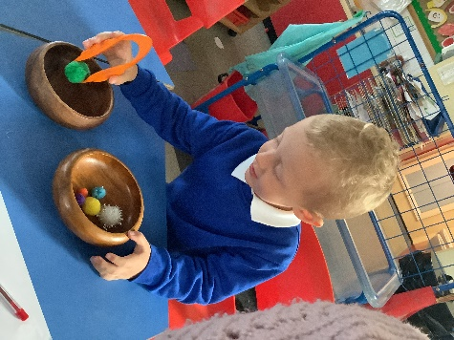

Physical activity is vital in children’s all-round development, enabling them to pursue happy, healthy and active lives. Gross and fine motor experiences develop incrementally throughout early childhood, starting with sensory explorations and the development of a child’s strength, co-ordination and positional awareness through tummy time, crawling and play movement with both objects and adults. By creating games and providing opportunities for play both indoors and outdoors, adults can support children to develop their core strength, stability, balance, spatial awareness, co-ordination and agility. Gross motor skills provide the foundation for developing healthy bodies and social and emotional well-being. Fine motor control and precision helps with hand-eye co-ordination, which is later linked to early literacy. Repeated and varied opportunities to explore and play with small world activities, puzzles, arts and crafts and the practice of using small tools, with feedback and support from adults, allow children to develop proficiency, control and confidence.

**In addition to the 3 prime areas there are 4 specific areas. These are:**

**Literacy**

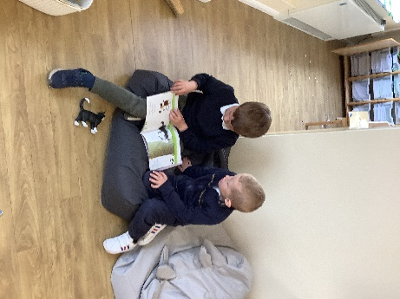

It is crucial for children to develop a life-long love of reading. Reading consists of two dimensions: language comprehension and word reading. Language comprehension (necessary for both reading and writing) starts from birth. It only develops when adults talk with children about the world around them and the books (stories and non-fiction) they read with them, and enjoy rhymes, poems and songs together. Skilled word reading, taught later, involves both the speedy working out of the pronunciation of unfamiliar printed words (decoding) and the speedy recognition of familiar printed words. Writing involves transcription (spelling and handwriting) and composition (articulating ideas and structuring them in speech, before writing).

**Mathematics**

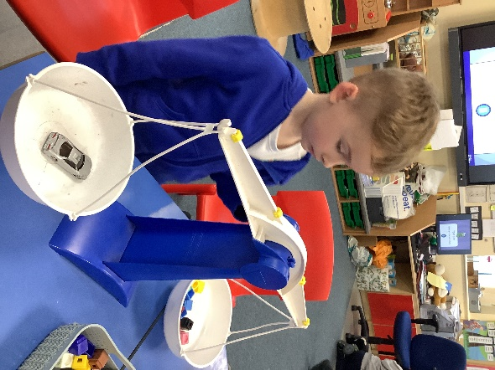

Developing a strong grounding in number is essential so that all children develop the necessary building blocks to excel mathematically. Children should be able to count confidently, develop a deep understanding of the numbers to 10, the relationships between them and the patterns within those numbers. By providing frequent and varied opportunities to build and apply this understanding - such as using manipulatives, including small pebbles and tens frames for organising counting - children will develop a secure base of knowledge and vocabulary from which mastery of mathematics is built. In addition, it is important that the curriculum includes rich opportunities for children to develop their spatial reasoning skills across all areas of mathematics including shape, space and measures. It is important that children develop positive attitudes and interests in mathematics, look for patterns and relationships, spot connections, ‘have a go’, talk to adults and peers about what they notice and not be afraid to make mistakes.

**Understanding the World**

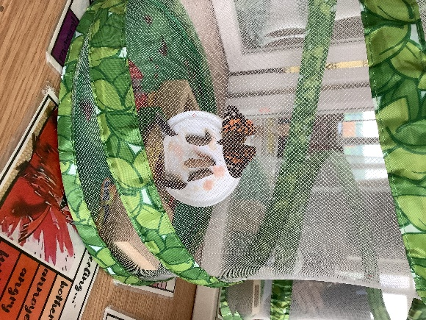

Understanding the world involves guiding children to make sense of their physical world and their community. The frequency and range of children’s personal experiences increases their knowledge and sense of the world around them – from visiting parks, libraries and museums to meeting important members of society such as police officers, nurses and firefighters. In addition, listening to a broad selection of stories, non-fiction, rhymes and poems will foster their understanding of our culturally, socially, technologically and ecologically diverse world. As well as building important knowledge, this extends their familiarity with words that support understanding across domains. Enriching and widening children’s vocabulary will support later reading comprehension.

**Expressive Arts and Design**

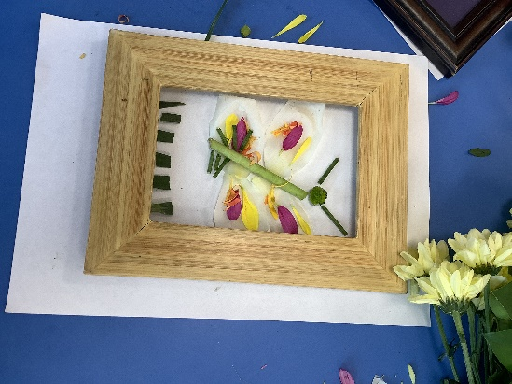

The development of children’s artistic and cultural awareness supports their imagination and creativity. It is important that children have regular opportunities to engage with the arts, enabling them to explore and play with a wide range of media and materials. The quality and variety of what children see, hear and participate in is crucial for developing their understanding, self-expression, vocabulary and ability to communicate through the arts. The frequency, repetition and depth of their experiences are fundamental to their progress in interpreting and appreciating what they hear, respond to and observe.

**Religious Education**

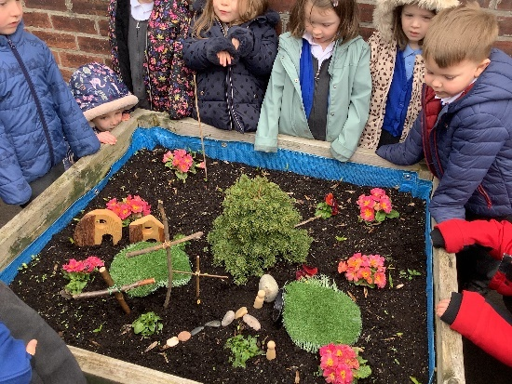

As a Church of England (Aided) Primary School we have regular, separate, RE lessons which your child will participate in. About half of the time this will be Christian in content. We will also learn about other religious world views for example Hindu Dharma, Islam and Judaism and non-religious world views when we learn about Humanism. We will teach RE in a variety of creative ways including art, music, food, outdoors, drama, ICT and story.

**How you can help us**

* Please make sure all items of school uniform and coats are named and regularly checked to ensure names are still visible. This saves time at playtimes, lunchtimes or at the end of the session trying to match it to the correct child as uniform often looks the same.
* Please let us know if someone different from usual is picking your child up from school and if possible let your child know this. We do not allow children to leave school with any adults unless we have prior notification from parents/carers.
* Please do not send sweets, biscuits, nuts or crisps to school for playtime. We provide fruit through the free fruit for school scheme. You can provide your child with their own piece of fruit, raisins or plain popcorn if you require.
* Children in Class 1 will receive free milk until their 5th birthday. After this you are welcome to pay for your child’s milk which can be ordered through a company called Cool Milk. This is an external company and not lead by school <https://www.coolmilk.com/>
* Children can bring their own named bottle of water into school each day. Please **do not** bring juice.
* As we will spend time outdoors as much as possible please be mindful of the weather. We have all in one rain suits if it is wet but the children may need an extra fleece to keep them warm in the winter or a sun hat and sunscreen in the summer. We do have some spare wellington boots but the children are welcome to bring their own. It may also be advisable to put a spare change of clothes in their bags.
* We run a tuck shop every Wednesday. Children can buy one or two items each week at a cost of 50p each. This includes orange or apple juice and a kit-kat or raisins. This can be paid for via Parent Pay.
* Help is given at mealtimes for cutting up certain foods though we do encourage the children to use a knife and fork correctly.
* If you are purchasing a book bag, please can you attach a key ring or other tag on their book bags to help children identify them quickly.
* Children do **not** need their own pencil cases or pens and pencils as we provide them in school. Storage and space are limited so we have no room to keep them. The children’s own toys are also not permitted in school as we would not like them to be lost, damaged or broken.
* We have two parent’s evenings during the year, one in October and one in February as well as written reports to let you know how your child is doing in school. As always though, if you need to see a teacher we are available every morning and evening at the gate, or alternatively please make an appointment through the school office.
* We will send out login details for Tapestry, our online learning journal, in September. This will be an opportunity for you to see some of the things your child participates in at school. We aim to upload a few observations every half term. Please feel free to upload any trips, special occasions or milestones from home too.
* Two ‘meet the teacher’ evenings – one for Nursery and one for Reception will take place in September where more information will be given on Phonics and Maths in Class 1.

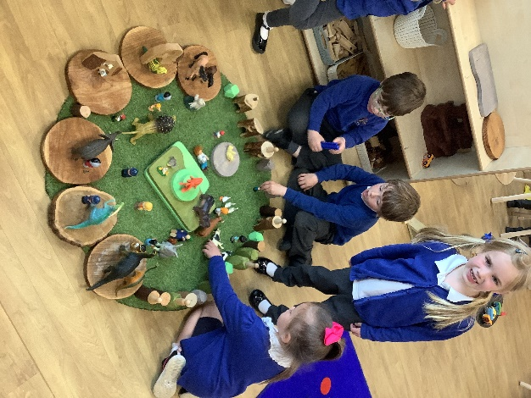

Fun